Pro Bono Economics/Civil Society Media results: 5 & 6 May 2020
Our weekly survey is designed to take the temperature of the civil society sector as the Covid-19 crisis continues to unfold, monitoring the pressures being faced by charities and voluntary organisations across the country and understanding how the picture is changing over time.
Over the course of 5 & 6 May 2020, a total of 126 respondents filled in the survey. The results showed:
- 94 per cent said they expected Covid-19 to have a negative impact on their ability to meet their charity objectives over the next six months, with half (50 per cent) saying they expected it to be a “large” negative.
- Nearly half (46 per cent) said their level of concern was broadly unchanged over the past seven days, but 52 per cent said that their expectations had deteriorated – with 15 per cent saying their level of concern had increased “a lot”.
- Nearly half (48 per cent) of the respondents said the single biggest issue they were facing was the impact of social distancing on their ability to deliver their services. Just over one-in-five (22 per cent) said that the way in which Covid-19 had affected their ability to fundraise was the biggest single issue. Just under one-in-five (18 per cent) instead pointed to its effect on their ability to plan for the future.
- Nearly all (96 per cent) of the respondents said they’d taken some form of action in response to the financial challenges raised by the crisis.
  - The most cited response was the furloughing of staff and use of the government’s Job Retention Scheme, with 61 per cent of respondents saying they’d done this.
  - A slightly lower proportion (56 per cent) said they’d reduced their activity in a significant way.
  - Just over half (52 per cent) said they’d sought funder flexibility on their spending plans, project delivery and reporting requirements.
  - More than two-in-five (44 per cent) said they had drawn down on their financial reserves.
  - Nearly one-in-four (23 per cent) said they’d applied for support from the government’s £750 million charity-specific package.

- When asked to rate the sufficiency of the government’s financial support for civil society in the face of Covid-19 (where 1 = entirely insufficient and 10 = entirely sufficient), the average score across all respondents was 4.5. One-in-three (68 per cent) scored the response at five or below, with two-in-five (40 per cent) scoring it 1-3 and one-in-ten (9 per cent) scoring it 8-10.
- There were indications of some important differences by size of charity, though modest sample sizes mean conclusions must be drawn with caution.
  - Smaller (annual income of less than £500k) and medium-sized (annual income between £500k and £10m) charities were more likely than large (annual income of £10m+) charities to say Covid-19 was having a negative impact on their ability to meet their objectives.
  - Small and medium charities were also more likely to cite the impact of social distancing on their ability to deliver services as being the single biggest challenge they are facing (59 per cent and 47 per cent respectively); whereas large charities were most likely to cite fundraising issues as the single biggest challenge (54 per cent).
  - Small charities (38 per cent) were much less likely than either medium (71 per cent) or large (77 per cent) charities to say they’d furloughed staff.
Commenting on the findings Matt Whittaker, Chief Executive of Pro Bono Economics, said:
“The charity sector is accustomed to working under pressure, but these latest results highlight the new pressures it is now having to deal with as a matter of course. The landscape has changed dramatically and there is little sign that the challenges are going to ease: rather, more than half of the respondents to the survey say they’ve grown more pessimistic over the last week.
“The overriding message from this week’s survey findings, and from the comments made by respondents, concerns the insufficient levels of financial support currently offered to the charity sector. Many organisations, both small and large, say they are in grave danger of falling through the cracks and that their long-term survival is at threat. Smaller charities feel that financial support is only being channelled to larger organisations, while larger charities say that there is a disproportionate – if understandable – focus on front-line services dealing directly with the COVID-19 crisis.
“It is clear that, if we want the sector to survive and to continue to make a vital contribution to society, these organisations need more financial support – and they need it now. Otherwise they won’t be in a position to help the people most in need as we emerge from lockdown.”

Figure 1: How do you expect Covid-19 to affect your charity’s ability to deliver on its objectives in the next six months?
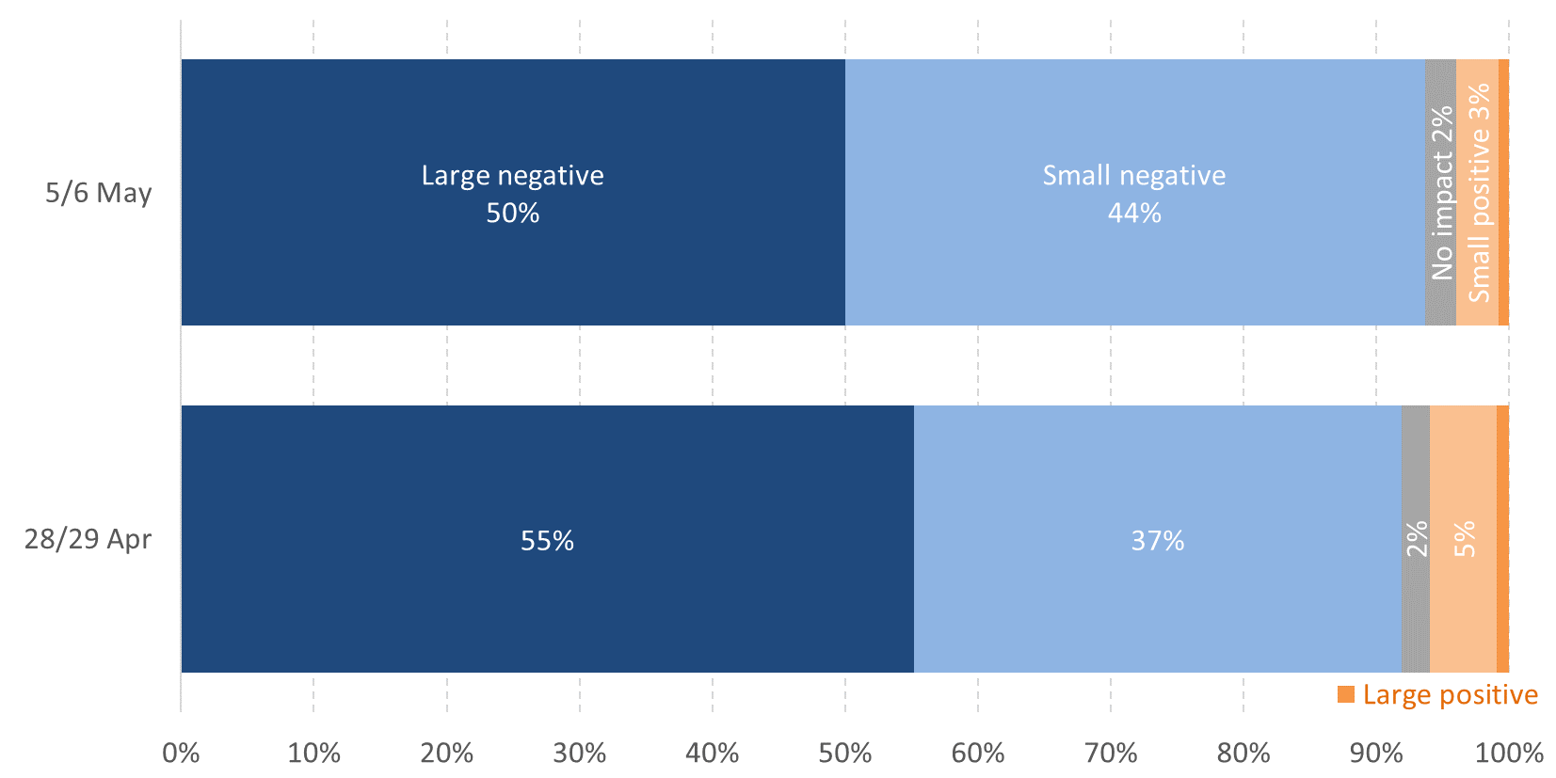
Notes: 28/29 Apr = 433 responses. 5/6 May = 126 responses.
Source: Charity responses to PBE & Civil Society Media survey.

Figure 2: How do you expect Covid-19 to affect your charity’s ability to deliver on its objectives in the next six months? 5-6 May, by charity size
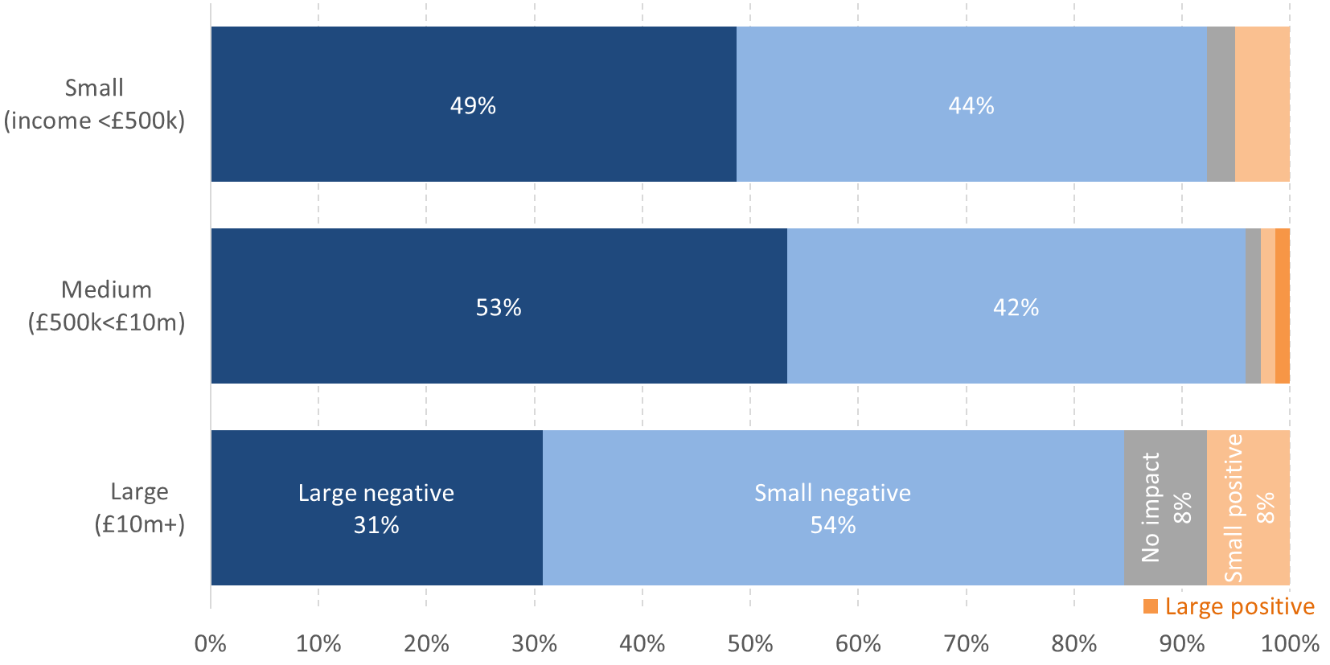
Notes: 126 responses, comprising 39 'small’, 73 'medium' and 13 'large'. Modest sample sizes mean these breakdowns should be treated with caution.
Source: Charity responses to PBE & Civil Society Media survey.

Figure 3: How has your level of concern about Covid-19’s impact on your charity’s ability to deliver on its objectives changed over the last seven days?
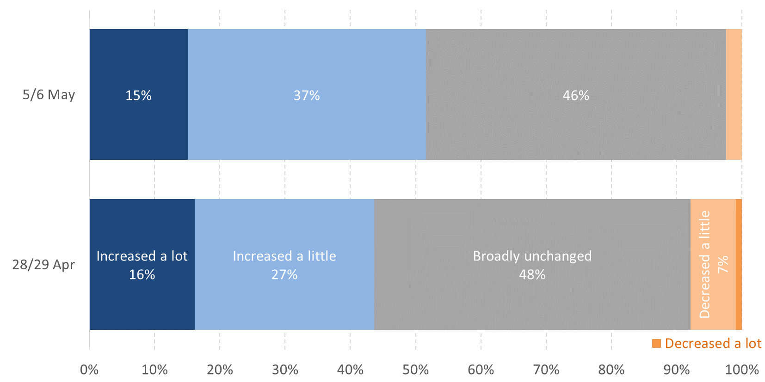
Notes: 28/29 Apr = 433 responses. 5/6 May = 126 responses.
Source: Charity responses to PBE & Civil Society Media survey.

Figure 4: How has your level of concern about Covid-19’s impact on your charity’s ability to deliver on its objectives changed over the last seven days? 5-6 May, by charity size
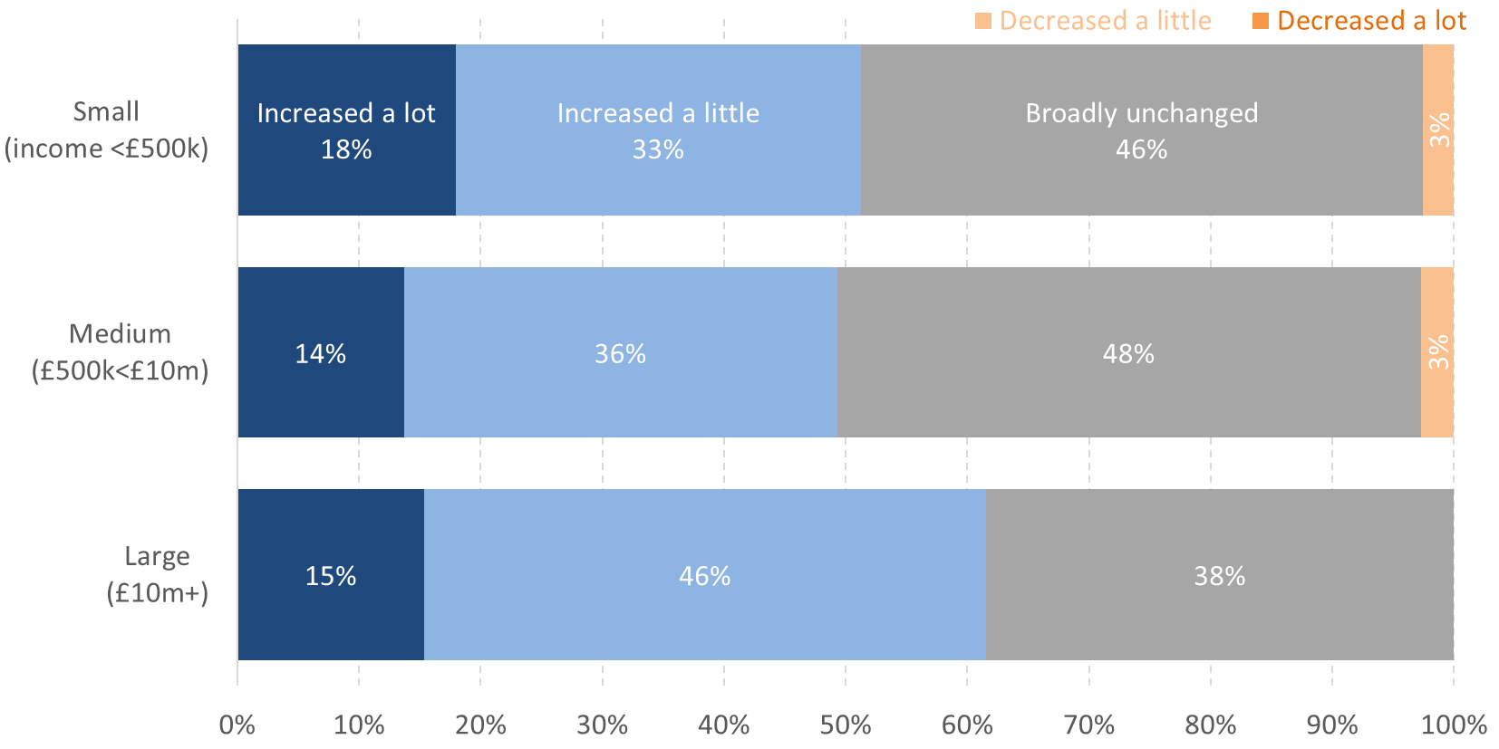
Notes: 126 responses, comprising 39 'small’, 73 'medium' and 13 'large'. Modest sample sizes mean these breakdowns should be treated with caution.
Source: Charity responses to PBE & Civil Society Media survey.

Figure 5: What is the current single biggest negative impact of Covid-19 on your charity’s ability to deliver on its objectives? 5-6 May
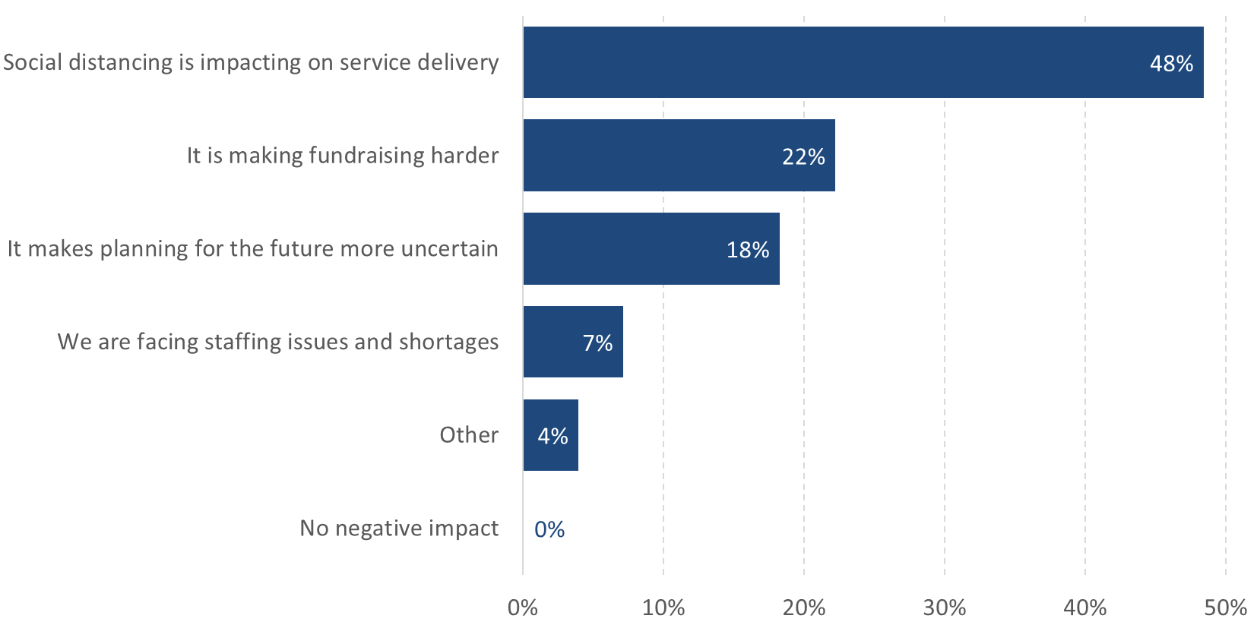
Notes: 126 responses.
Source: Charity responses to PBE & Civil Society Media survey.

Figure 6: What is the current single biggest negative impact of Covid-19 on your charity’s ability to deliver on its objectives? 5-6 May, by size of charity
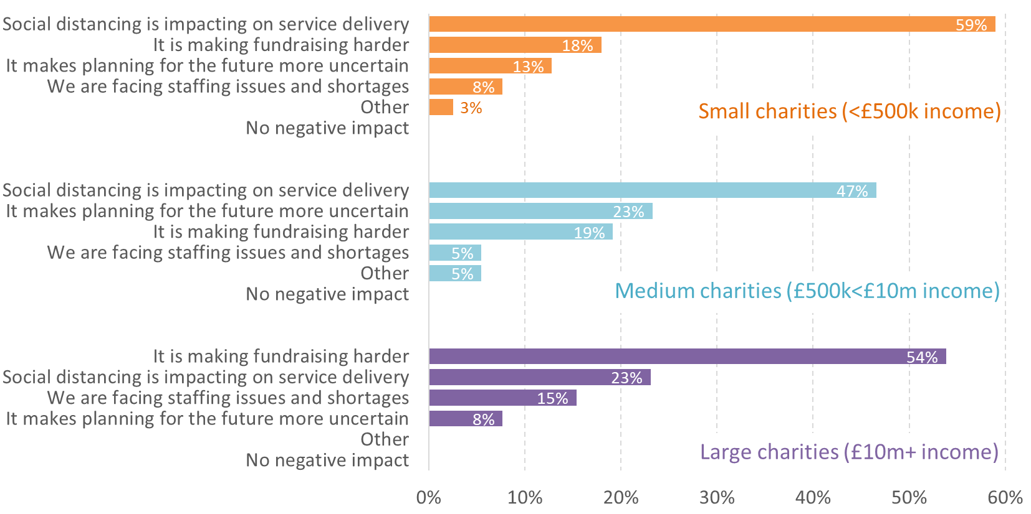
Notes: 126 responses, comprising 39 'small’, 73 'medium' and 13 'large'. Modest sample sizes mean these breakdowns should be treated with caution.
Source: Charity responses to PBE & Civil Society Media survey.

Figure 7: What actions have you taken in response to any financial challenges that Covid-19 have presented to your organisation? 5-6 May
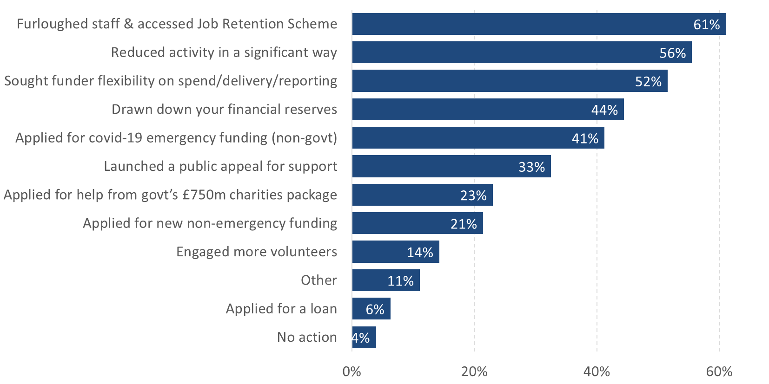
Notes: 126 responses. Respondents were asked to tick all options that applied.
Source: Charity responses to PBE & Civil Society Media survey.

Figure 8: What actions have you taken in response to any financial challenges that Covid-19 have presented to your organisation? 5-6 May, by size of charity, top five shown
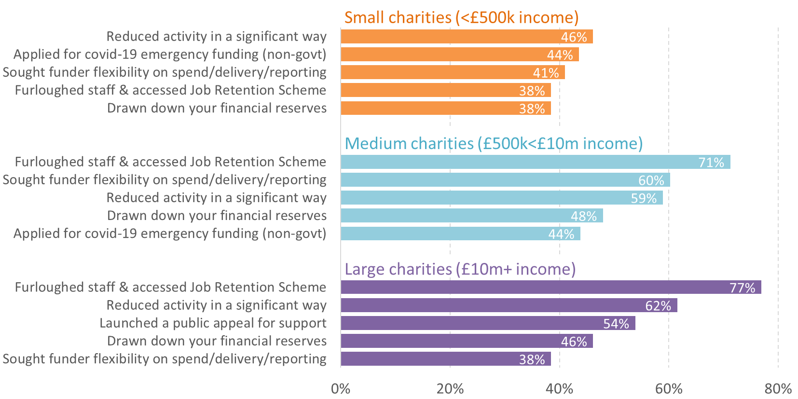
Notes: 126 responses, comprising 39 'small’, 73 'medium' and 13 'large'. Modest sample sizes mean these breakdowns should be treated with caution. Respondents were asked to tick all options that applied.
Source: Charity responses to PBE & Civil Society Media survey.

Figure 9: On a scale of 1-10 (1=“entirely insufficient”; 10=“entirely sufficient”) how would you score the Covid-19 financial help being provided to civil society by govt? 5-6 May
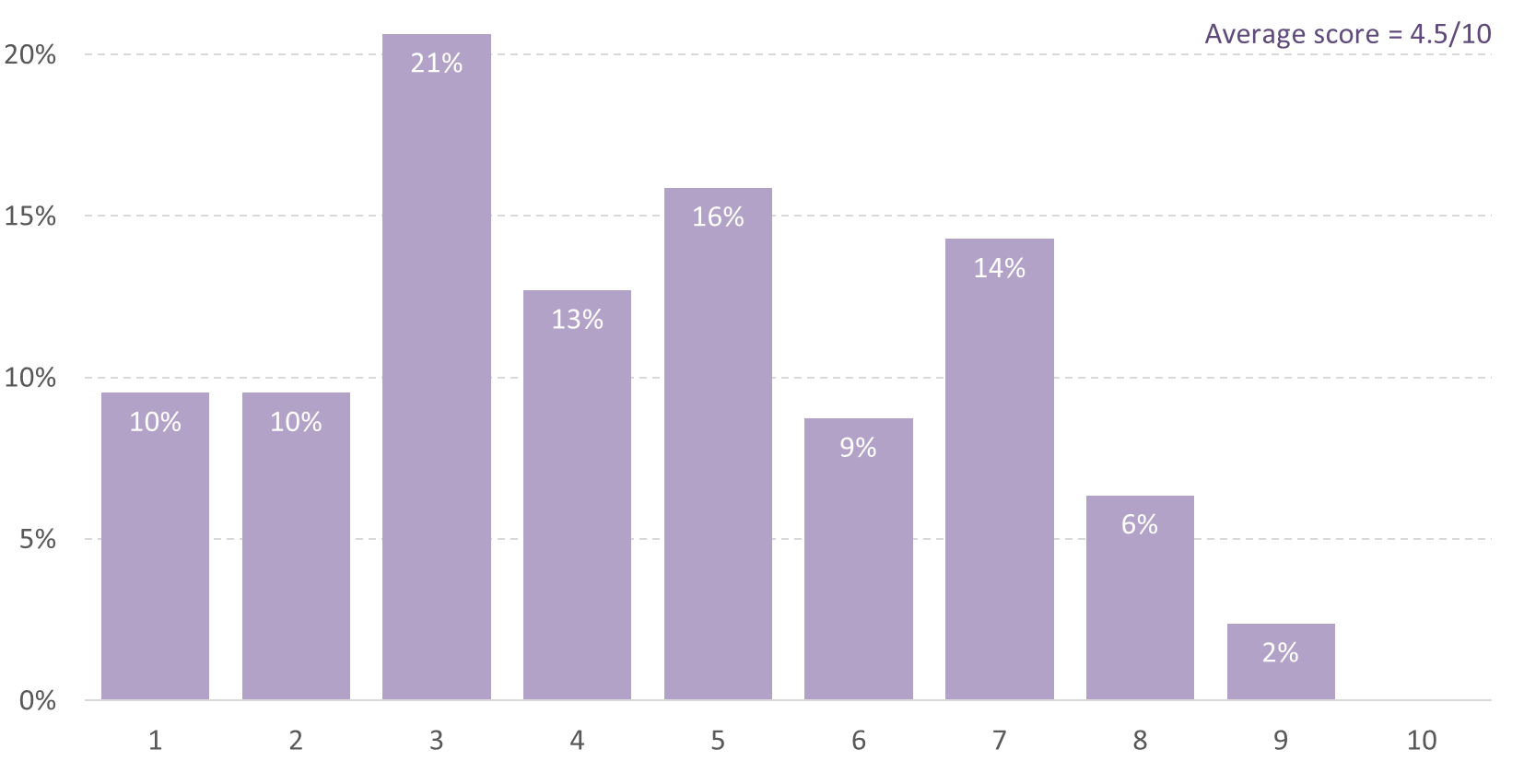
Notes: 126 responses.
Source: Charity responses to PBE & Civil Society Media survey.

Figure 10: Add your comment on what Covid-19 means to your organisation and what more the government, funders or others could be doing to support you: 5-6 May (selection)
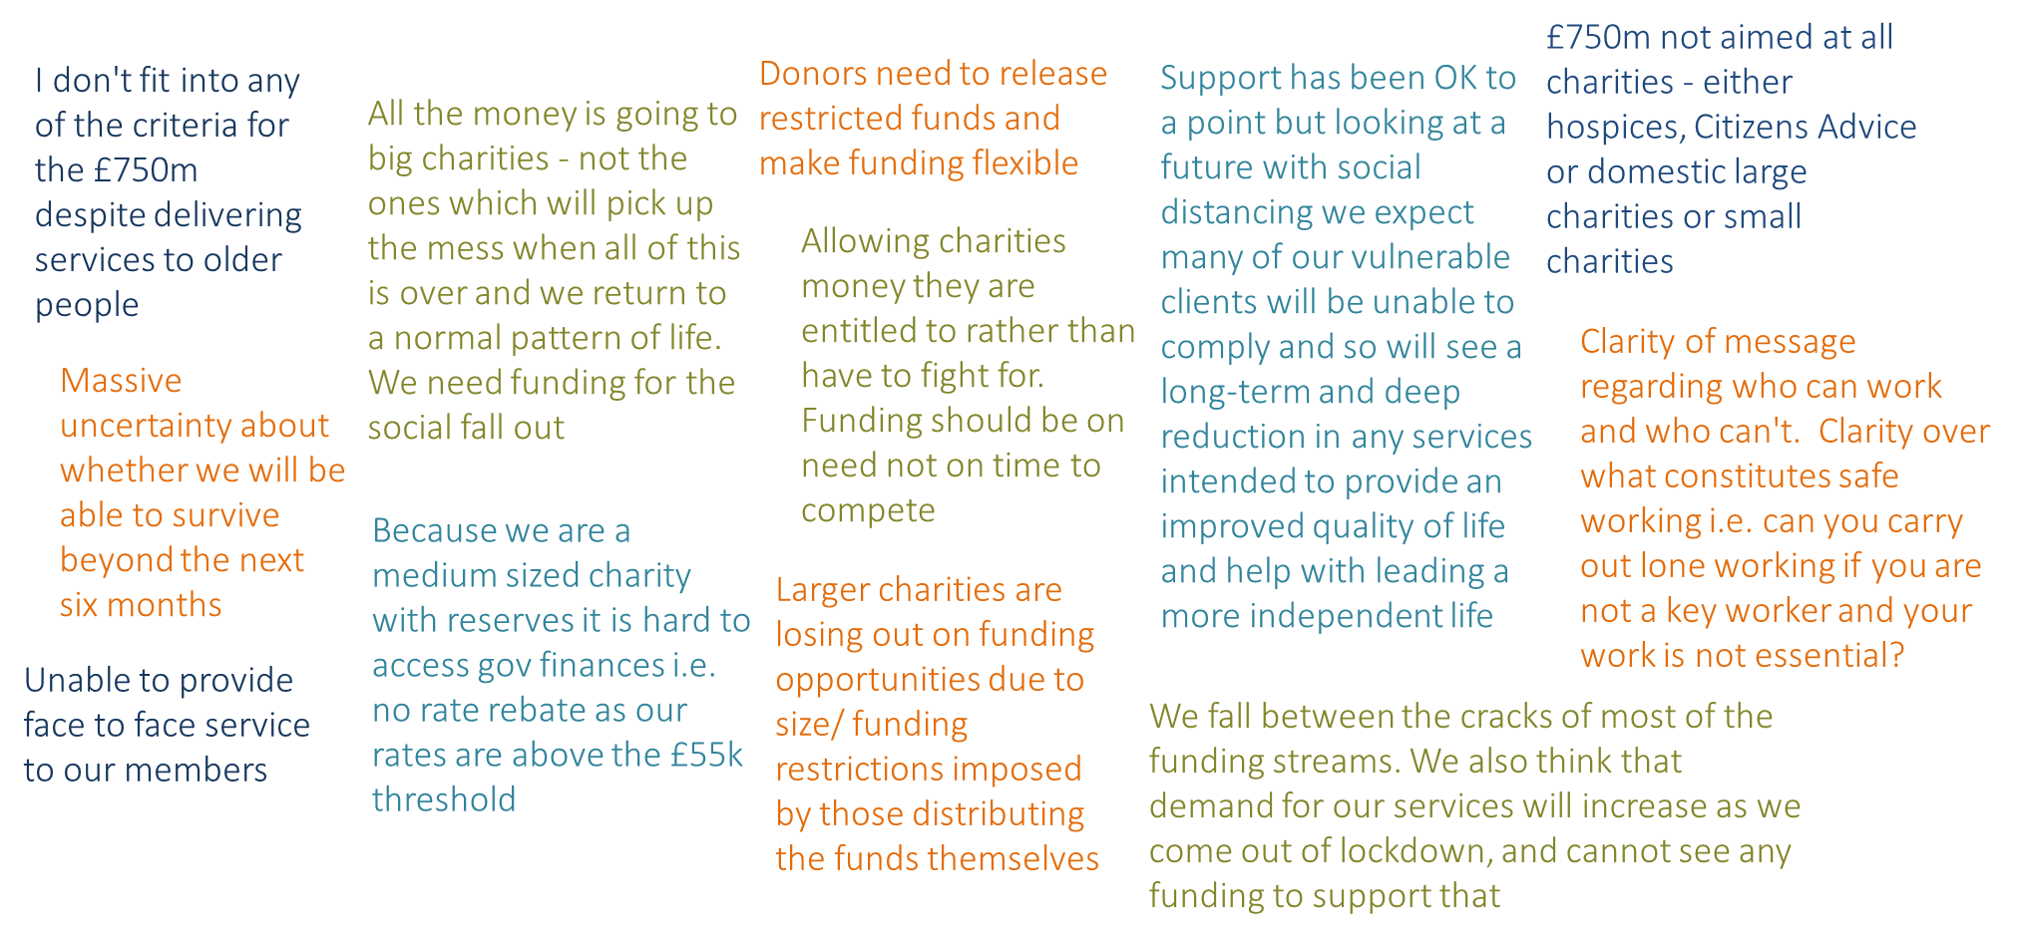
Notes: 126 responses.
Source: Charity responses to PBE & Civil Society Media survey.

